Title of the Event | PG Talent Hunt “Anusmiriti” | 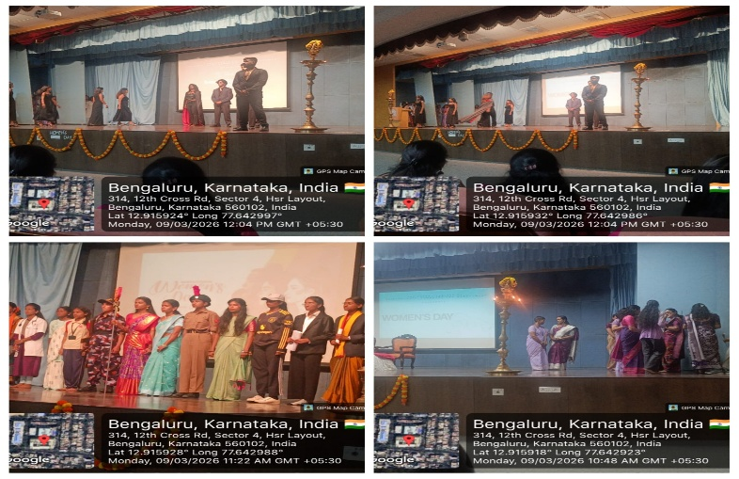
Day and Date | 9 March 2026
Venue (With all details ) | Auditorium
In collaboration with ( if any)
Details of Resource Person With Designation |  | 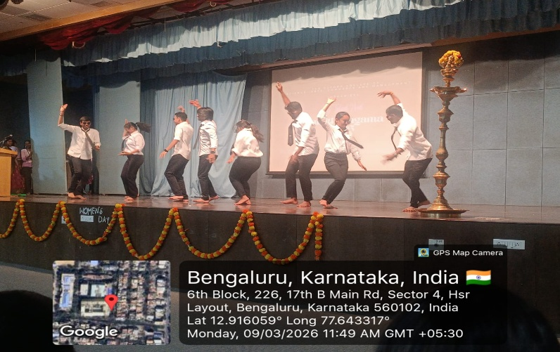
Organizing Department/Coordinators | Commerce and Management Department
Course and semester | PG Management students
No of Students & Faculty Participants | 70

Coordinator HoD Vice-Principal Principal

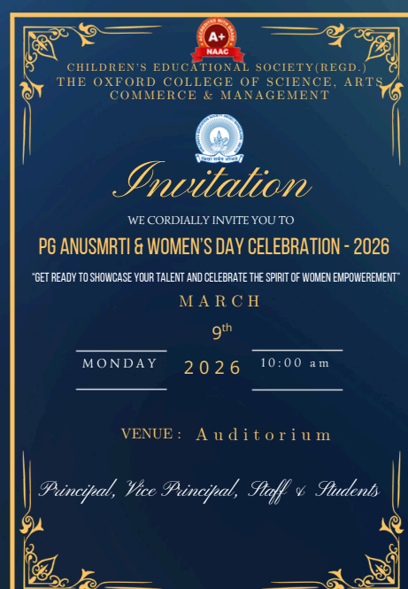
Introduction
The Department of Commerce and Management of The Oxford College of Science, Arts, Commerce and Management organized and participatedin PG Anusmrti & Women’s Day Celebration – Talent Hunt on 9 March 2026 (Monday) at 10:00 AM in the Auditorium. The program was conducted to celebrate International Women’s Day and to provide a platform for students to showcase their talents and creativity.
Description of the Activity
Students from the Department of Commerce and Management, including MBA students, actively participated in the event. The program included various cultural activities such as group dance, fashion walk, and other performances presented by the students. The group dance performances highlighted teamwork and creativity, while the fashion walk showcased confidence and elegance.
Outcome of the Activity
The PG Talent Hunt helped students develop confidence, teamwork, and stage presence. It also encouraged students to express their creativity and celebrate the spirit of women’s empowerment.
Conclusion
The PG Anusmrti & Women’s Day Celebration , Talent Hunt 2026 was successfully organized by the Department of Commerce and Management. The event provided a memorable opportunity for students to showcase their talents and celebrate International Women’s Day

